Model RFQ for Fire & Gas Mapping
  - Version: 12 Sep 2016

Table of Contents
1. Scope 4
2. Terms and Abbreviations 4
2.1 Terms 4
2.2 Abbreviations 4
3. Reference Documents 4
3.1 Reference Drawings 4
3.2 COMPANY Standards 5
3.3 External Standards 5
3.4 Potential Document Conflicts or Errors 5
4. Study Objectives 5
5. Study Methodology 6
5.1 Fire and Gas Zone Definition 6
5.2 HAZID and FGS Function Development 7
5.3 Analyze Risk and Define FGS Performance Targets 7
5.4 Design Basis Consequence Modeling 8
5.5 Detector Technology Assessment 9
5.6 Fire and Gas Mapping for Coverage Verification 9
5.7 FGS Function Safety Availability (SIL) Verification 11
5.7 FGS Requirements Specifications 11
5.8 FGS Verification and Validation 12
6. Study Deliverables 13
7. Project Schedule 13
8. Meetings and Presentations 13
9. Information to be Presented in the Proposal 13
10. Basis of Commercial Proposal 14
Appendix A – Facility Description 15
Appendix B – FGS Zone List and Zone Extents Drawing 17
Appendix C – FGS Function List – Typical 20
Appendix D – FGS Performance Target List 22
Appendix E – Design Basis Consequence Modeling Results 25
Appendix F – Typical Fire and Gas Mapping Results 26
Appendix G – Typical FGS Requirements Specifications Components 30

Scope
This document defines the scope of work for Fire & Gas Mapping to be performed for the facilities described in Appendix A – Facility Description.

Terms and Abbreviations

2.1 Terms
COMPANY (Name of Operating Company)
ENGINEER (Name of Engineering Company, if subcontracted through third party)
CONSULTANT Entity contracted by COMPANY or ENGINEER to perform the scope of services contained in this document
SCOPE OF WORK The work required to complete the Performance-Based Fire and Gas Detection and Suppression System Design Basis, as detailed in this document, for the facilities described in Appendix A – Facility Description

2.2 Abbreviations
F&G Fire and Gas
FGS Fire and Gas System
FM Factory Mutual

Reference Documents
The project documentation, codes, standards, and other documents that define the scope of this project and the limitations and expectations under which the project is to be executed are listed in the following sections.

3.1 Reference Drawings
Drawing Number | Title
 | Process Flow Diagrams
 | Piping and Instrumentation Diagrams

3.2 COMPANY Standards
Document Number | Title
 | Fire & Gas System Philosophy

3.3 External Standards
Document Number | Title
ISA TR 84.00.07 | Guidance on the Evaluation of Fire and Gas System Effectiveness
IEC 61511 | Functional safety: Safety Instrumented Systems for the process industry sector

3.4 Potential Document Conflicts or Errors
The documents that are referenced in Section 3 of this document are incorporated by reference into this request for proposal document. If any errors of conflicts are found to occur within this proposal document or the incorporated reference documents, the conflicts shall be brought to the attention of ENGINEER or COMPANY for resolution.

Study Objectives
The primary objective of this study is to develop a design-basis for the implementation of a fire and gas detection system. At the conclusion of the study the facility, as described in Appendix A – Facility Description, shall be completely defined in terms of detector layout. The study shall include the following, tasks with associated deliverable documents:
- Definition of Major Equipment, Process Streams, and Hazards
- Analyze Risk and Define FGS Performance Targets, including:
  - Classify each zone
  - Grade all zones classified as a process area
  - Develop zone extents diagrams (where applicable
  - Assign detector coverage targets (where applicable)
  - Assign FGS function safety availability (SIL) target (where applicable)
- Perform Design Basis Consequence Modeling
- Perform detector technology assessment to facilitate detector technology selection
- Perform Fire and Gas Mapping to verify that the proposed detector layout achieves coverage performance targets

Study Methodology
The study shall be performed in accordance with the methodologies and constraints specified in the following sections.

5.1 Definition of Major Equipment, Process Streams, and Hazards
CONSULTANT shall review the scope of facilities of this project (as defined in Appendix A – Facility Description) in order identify the major equipment items, identify the hazardous process streams associated with this equipment, and classify the hazards associated with those process streams. This includes identifying the typical process material(s), normal operating conditions, and whether the materials processed contain hydrocarbon fire hazards, combustible gas hazards, or toxic gas hazards. Major equipment items to be listed include storage tanks, pressure vessels, pumps, compressors, separation equipment, heat exchangers, wellheads, manifolds, etc.
Once streams have been assigned to each equipment item, the hazards will be listed for each major piece of equipment. The outcome of a hazard depends on the process fluid composition (representative stream), the process conditions (temperature and pressure), the size and duration of the release, and the type and location of ignition sources.
The result of this task is a preliminary equipment item list (with associated stream and hazard classifications).

5.3 Analyze Risk and Define FGS Performance Targets
CONSULTANT shall conduct and document a risk analysis where the appropriate performance targets for each FGS function are defined. The risk analysis and associated documentation shall be performed in accordance with COMPANY procedures for performance based fire and gas system design. Each zone is assigned a category to determine performance requirements for fire and gas detection, which includes targets for detector coverage. Each FGS function with a hydrocarbon zone shall be assigned a safety availability (SIL) target. The analysis shall be based on risk of safety and/or commercial impacts of fire and gas releases in the zone. The risk ranking analysis shall result in a fire grade or gas grade, which forms the basis for assigning the performance targets. The risk analysis shall be performed by a facilitator that has experience in performing performance based FGS categorization and grading studies (minimum of two studies).
The analysis shall consider the following factors.
- Assessment of the Hydrocarbon Processing Equipment
  - Potential credible sources of hydrocarbon in the zone
  - Ignition Sources
  - Concentrations of toxic gases in processing fluids
- Assessment of Fire and Gas Consequences
  - Determine release scenarios which the system is intended to protect against
  - Identify confinement and congestion in the process areas that could aggravate flammable gas hazards, e.g., open grating versus solid decking
  - Consider safety related consequences including personnel and public safety
- Assessment of release likelihood
  - Aggregate likelihood of release from all identified release sources to determine overall likelihood
  - Determine the potential for small hazard escalation
- Assessment of level of human occupancy
The results of this risk analysis, in accordance with COMPANY procedure, shall define the required performance targets. A typical FGS Performance Target List and FGS Grade Extents diagram are shown in Appendix D – FGS Performance Target List.

5.4 Design Basis Consequence Modeling
CONSULTANT shall perform design basis consequence modeling in order to determine the expected physical extents of the typical scenarios that are expected for the facility under study. Consequence modeling shall be used to determine the design basis of the fire and gas detection and suppression system. CONSULTANT shall ensure a proper understanding of the potential consequences of a hazard so that an appropriate degree of integrity can be specified. Hazards safeguarded with FGS can be difficult to assess in a qualitative manner, and it is often desirable to quantitatively assess the degree and magnitude of the potential hazardous outcome. These outcomes could include a pool fire, jet fire, combustible gas cloud dispersion with a vapor cloud fire / explosion, toxic gas cloud formation and dispersion.
A series of credible design-basis scenarios shall be selected for modeling by a team of experts. The assessment of consequences is done using computerized modeling to determine the size and extent of these hazardous outcomes. The hazards are then assessed in terms of the potential impact to onsite or offsite personnel, the environment, or in terms of equipment damage. The design basis consequence modeling can then be used with the customer’s risk management guidelines to accurately determine the severity of the hazard; and an appropriate degree of integrity is selected for safeguards that will detect and prevent the hazardous condition.
The results of the design basis consequence modeling shall be included in the Fire and Gas Mapping Report, and shall include length and width estimates for the various consequence types along with “footprint” colorized maps for each modeled scenario. Typical results of design basis consequence modeling are presented in Appendix C – Design Basis Consequence Modeling Results.

5.5 Detector Technology Assessment
CONSULTANT shall perform a detector technology assessment whose results shall be used to select the most appropriate detector technology for all of the detection applications of the study. CONSULTANT shall list all available detector technologies for fire detection and gas detection. Each technology will be described with respect to its strengths and weaknesses, along with a listing of the attributes that can affect performance, such as reflected light, spurious radiation sources, etc. Subsequently, the facility shall be considered, along with a listing of the performance affecting attributes that are present in the zones. A comparison of the performance affecting attributes of each zone against the relative strengths and weaknesses of each detector type shall be made and shall result in the selection of detector technology for all of the zones.
The results of the detector technology assessment shall be documented in the Fire and Gas Mapping report.

5.6 Fire and Gas Mapping for Coverage Verification
CONSULTANT shall perform fire and gas mapping to verify that the coverage targets that were selected for each fire and gas zone are achieved by the proposed design. The mapping study shall consider the following factors.
- The proposed layout and orientation shall be assessed to ensure the following
  - To ensure the coverage footprint is sufficient to provide the required hazard alarms and control actions
  - To ensure that detector views are not impeded by pipe work, cable trays, or other obstructions.
- The effective range of the selected detectors shall consider the expected environment, with the estimate based on test data
The fire and gas mapping study shall be of the geographic coverage variety for fire detection arrays and scenario coverage (or geographic coverage) for gas detection arrays. The geographic coverage shall calculate the fraction of the area of a monitored process zone that, if a fire release would occur, would be detected. Scenario coverage shall calculate the fraction of the release scenario frequency that, if a gas release would occur, would be detected.
The fire and gas mapping shall be performed utilizing a computer aided design tool that will generate a colorized map of the coverage provided in a zone, along with tabulated and calculated results. The fire and gas mapping tool shall have, at a minimum, the following attributes for fire modeling.
- Perform modeling in three dimensions
- Import 3D models developed in CAD software and also allow modification of the 3D model of the plant by adding geometric shapes into the model, as required
- Calculate the analysis results for any user-selected elevation of interest
- Accurately model any make and model of fire detector (i.e., the results of the computer software shall create a map that is essentially identical to the “cone of vision” presented in each equipment vendor’s product literature when the detector is located at the elevation of interest and oriented with no angle of declination)
- Accurately model the effects of changes in detector elevation away from the elevation of interest
- Accurately model the effects of changing angle of declination with respect to the elevation of interest
- Accurately model multiple different detector sensitivity settings for each detector
- Accurately model multiple fires from different materials of interest for each detector as required (e.g., methanol fires, methane fires, hexane fires)
- Automatically recalculate the extents of the cone-of-vision based on changes in target fire size
- Accurately model the impact of obstructions to fire detector view in full three dimensions
- Accurate model multiple obstruction geometries, including but not limited to, cubes (cuboid), spheres, cylinders, cylindrical vessels – horizontal and vertical)
- Consider the complete volume of the fire in the coverage analysis (i.e., considers the fraction of the fire volume that is obstructed and not obstructed when determining whether or not a design basis fire is covered
- Allows for user definition of the fire plume size for volumetric analysis of the fire plume
- Present tabular results of the area where
- No detectors are sighted
- A single detector is sighted
- Two or more detectors are sighted
- Present a color coded map of the elevation of interest showing where
- No detectors are sighted
- A single detector is sighted
- Two or more detectors are sighted
- Limit graphic results and tabulated results to the fire grading extents instead of the overall zone.
- Present multiple independent results for the multiple zone grades that may be present in a zone.
The fire and gas mapping tool shall have, at a minimum, the following attributes for gas modeling.
- Perform modeling in three dimensions
- Perform modeling for combustible gases and for toxic gases
- Perform geographic coverage and scenario coverage
- Modeling of point detection systems along with open path detection systems
- Present graphical results at any user selected elevation of interest
- Present tabular results of the area where
- No detectors are sighted
- A single detector is sighted
- Two or more detectors are sighted
- Overall release frequency
- Fraction of release scenarios detected (i.e., scenario coverage)
- Present tabular results for either a single elevation or fully in three dimensions for the entire three-dimensional room space
- Present a color coded map of the elevation of interest showing where
- No detectors are sighted
- A single detector is sighted
- Two or more detectors are sighted
- Present a color coded map of the elevation of interest showing
- Frequency of existence of any gas cloud in any given location of a monitored area
- Frequency of existence of gas clouds in any given location of a monitored area that are not detected by the gas detection array
- Limit graphic results and tabulated results to the gas grading extents instead of the overall zone.
- Present multiple independent results for the multiple zone grades that may be present in a zone.
All fire and gas mapping shall be performed by personnel who are certified by the software vendor to be qualified to perform fire and gas mapping studies and qualified to use the fire and gas mapping software. All mapping scenarios shall be certified by the software vendor as being accurate and representative with respect to the documentation that describes each fire and gas mapping scenario.
The results of the study shall be presented as one fire coverage map and two gas coverage maps (one scenario coverage and one geographic coverage for each zone, with tabulated results of the mapping analysis. The results of the analysis will also be presented in the form of a detector list that shows all of the detectors that were employed in their study and provides information regarding their location, orientation, type, and settings. For typical fire and gas detection mapping results, see Appendix D – Typical Fire and Gas Mapping Results.

Study Deliverables
The project described in this request for proposal shall result in the following documents, drawings, and specifications as a result of the study work.
- FGS Study Report describing the scope methodology and results of the study, including the following work products as appendices:
- Zone List
- Zone Grading
All deliverables shall be submitted in a fixed (non-editable) format, e.g., Adobe PDF or equal, and in the native editable format, e.g., Microsoft Word, or equal.

Project Schedule
<<Insert project schedule requirements into this location as dictated by project conditions>>

Meetings and Presentations
The scope of the project shall include the following meetings and presentations to be performed at COMPANY site, professional fees and travel and living expenses are to be included in the fixed price submitted by CONSULTANT.
- Kick-Off Meeting
- Site Survey
- Preliminary Results Review Meeting
- Final Results Presentation

Information to be Presented in the Proposal
The proposal generated by CONSULTANT for this SCOPE OF WORK shall include the following information in order to be considered in compliance with this Request for Quotation.
- Description of the Scope of Work Proposed by Consultant
- Methodology to be implemented, including acceptance criteria
- Assumptions upon which the proposal is based
- Assumptions utilized during study execution for technical tasks
- Details of all software tools implemented
- Details of sources of references and databases implemented
- Composition of the study team, including resume of key personnel
- Competency justification for key personnel
- Proposed schedule for project execution
In addition, any clarifications, qualifications, or exclusions by CONSULTANT to the Scope of Work contained herein shall be clearly listed separately. If no clarifications, qualifications, or exclusions are noted by CONSULTANT in their proposal document, the CONSULTANT shall be considered in full compliance with the scope of work requirements.

Basis of Commercial Proposal
The commercial proposal shall be in compliance with the terms and conditions of COMPANY or ENGINEER standard purchasing terms and conditions for technical service projects (standard terms and conditions are attached).
The proposal shall be prepared on the basis of a fixed price for services and expenses. Time and materials proposals shall not be accepted. The scope of work is well defined. As such, the level of effort is clearly determinable by a competent consultant. Inability to provide a fixed price lump-sum quotation shall be considered a lack of competency of the CONSULTANT to perform these services, resulting in a rejection of the proposal.

Appendix A – Facility Description
<<INSERT FACILITY DESCRIPTION HERE>>

Appendix B – Typical FGS Performance Target List
Item | Zone ID | Zone Description | Zone Type | Graded Areas |  |  |  |  |  |  |  |  |  |  |  |  |  |  |  |  | Graded Areas
 |  |  |  | Graded Area Tag | Equipment List
 |  |  |  |  | Equip Tag | Equip Type | Hazard Type | Leak Scenarios
 |  |  |  |  |  |  |  | Leak Description | Hole Size | Item Leak Frequency | HC HAZARD RANKING
 |  |  |  |  |  |  |  |  |  |  | Consequence (Risk Matrix) |  |  | Rank Criteria |  | Ignition Probability | F(unmit) | Safety Grade | Asset Grade | Env. Grade
 |  |  |  |  |  |  |  |  |  |  | Severity - Safety | Severity - Asset | Severity - Environment | Hazard Rank (Release Rate) | Hazard Rank (Occupancy) |  |  |  |  |  | Selected Grade
6. | Zone 6 | Gas Plant - Process Area | H - Hydrocarbon | Z5-1 | C-104 | 1E-1 | Comb. Gas | Small Leak of HP Gas from Export Gas Compressor | 5 mm | 9.2E-02/yr | 3 | 3 | 3 | <1 kg/sec | <=50% | 0.01 | 4.60E-04/yr | None | A | None | A
 |  |  |  |  |  |  |  | Large Leak of HP Gas from Export Gas Compressor | 25 mm | 8.0E-03/yr | 4 | 3 | 3 | 1 to 50 kg/sec | <=50% | 0.07 | 2.80E-04/yr | C | B | None
 |  |  |  | Z5-2 | P-103 | WH | Liquid HC |  | 5 mm | 2.8E-03/yr | 4 | 3 | 5 | 1 to 50 kg/sec | <=50% | 0.07 | 9.66E-05/yr | None | None | None | B
 |  |  |  |  |  |  |  | Leak of Stabalized Liquid From Export Pump | 25 mm | 2.4E-04/yr | 5 | 4 | 6 | >50 kg/sec | <=50% | 0.30 | 3.60E-05/yr | C | B | B
 |  |  |  | Z5-3 | V-101 | SV | Comb. Gas | Leak of HP Gas from High Pressure Separator | 5 mm | 9.2E-04/yr | 4 | 4 | 2 | 1 to 50 kg/sec | <=50% | 0.07 | 3.22E-05/yr | None | B | None | B
 |  |  |  |  |  |  |  |  | 25 mm | 8.0E-05/yr | 5 | 4 | 2 | >50 kg/sec | <=100% | 0.30 | 2.40E-05/yr | C | C | None
 |  |  |  |  | V-102 | SV | Comb. Gas | Leak of LP Gas from Low Pressure Separator

FGS Zone Grading
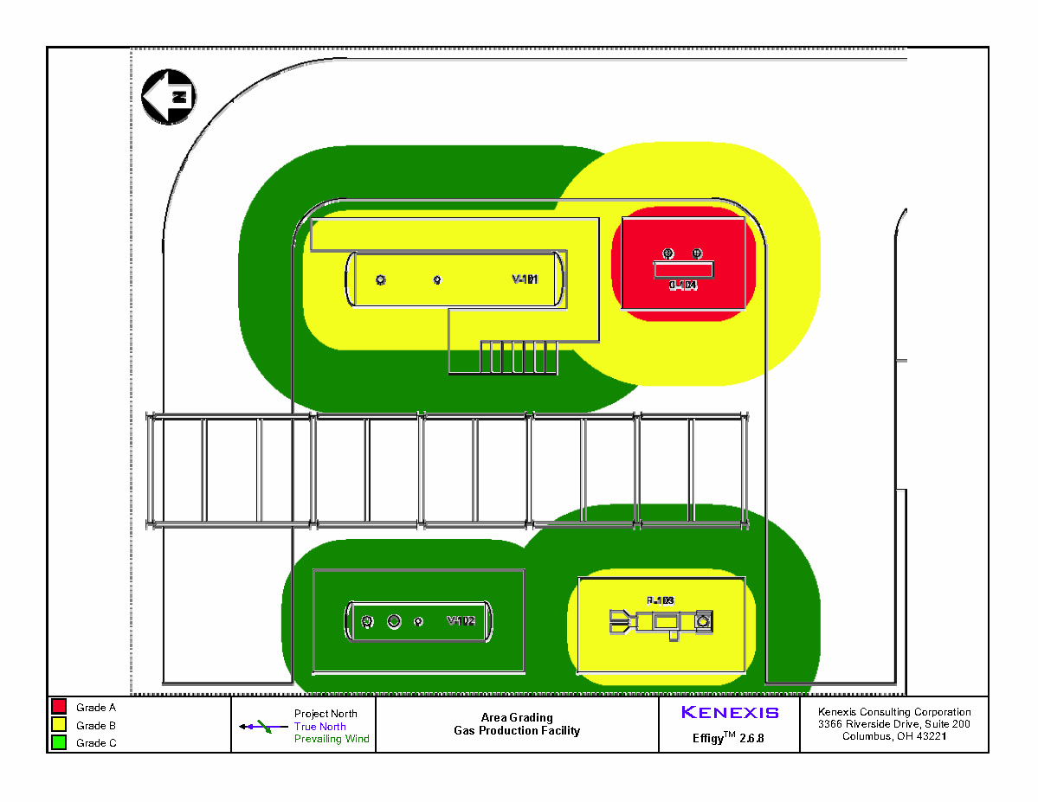

Appendix C – Design Basis Consequence Modeling Results
The following figures show typical results of design basis consequence modeling.
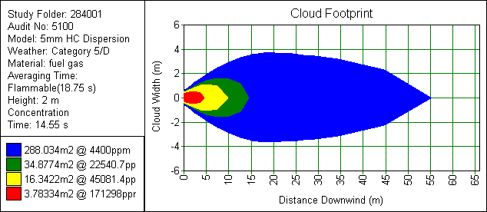
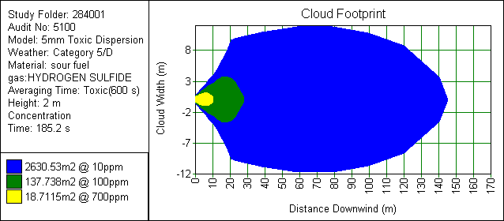
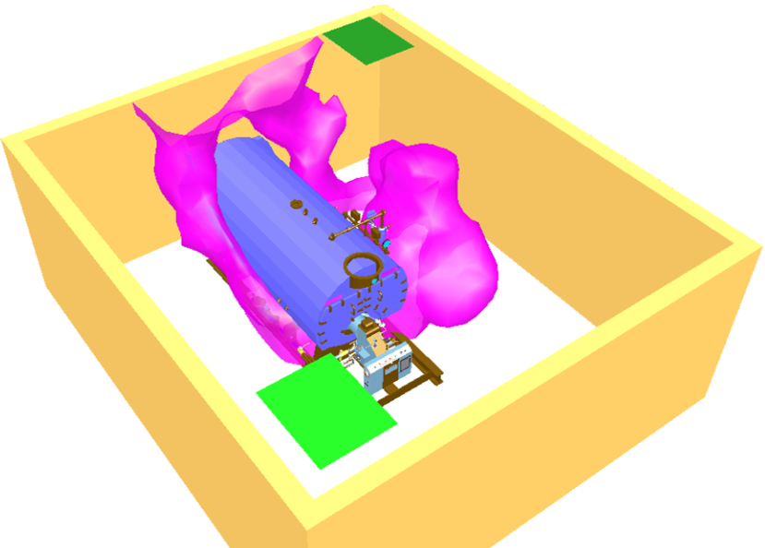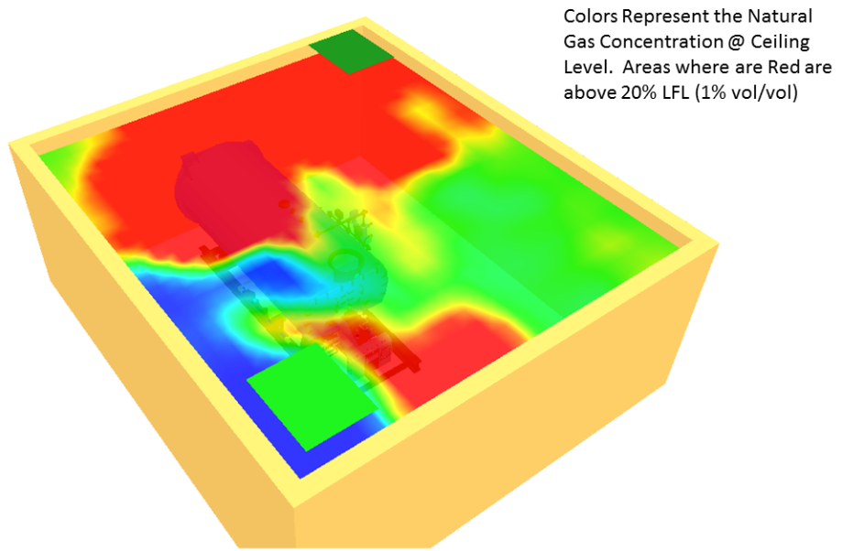

Appendix D – Typical Fire and Gas Mapping Results
Geographic Fire Coverage
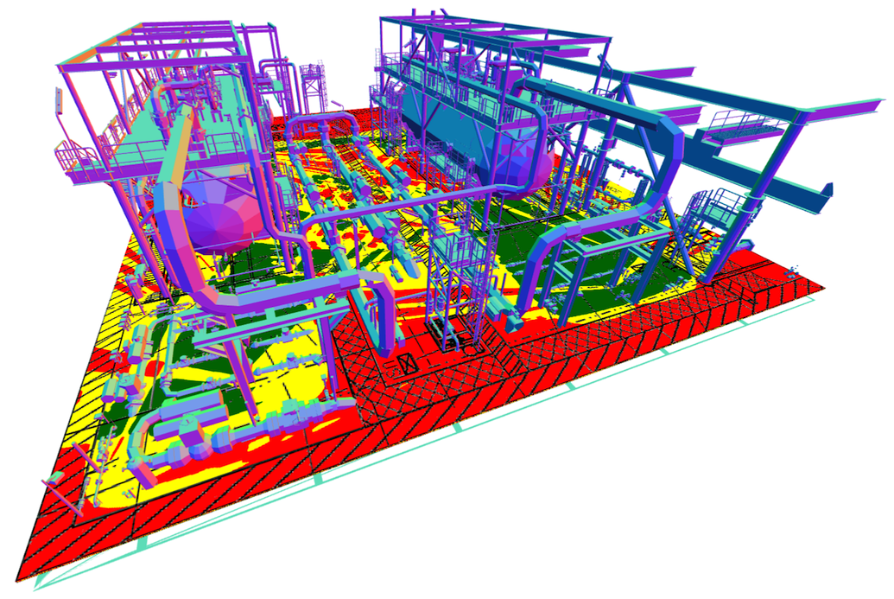
Gas Coverage – Scenario and Geographic
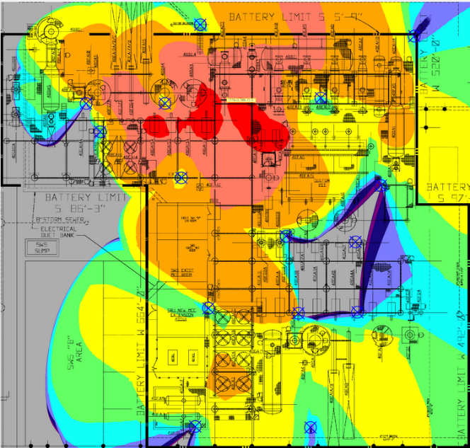

Typical Detector List
The following figure presents a typical fire and gas detector list.
Detector Type | Tag | X Coordinate | Y Coordinate | Elevation Above Grade | Rotation (deg) | Declination (deg) | Notes
Point Source Gas Detector (HC) | BTX-001 | 27' 6" N | 26' 0" E | 6’ 0” | N/A | N/A
Point Source Gas Detector (HC) | BTX-002 | 54' 6" N | 14' 6" E | 6’ 0” | N/A | N/A
Point Source Gas Detector (HC) | BTX-003 | 15' 0" N | 14' 6" E | 6’ 0” | N/A | N/A
Point Source Gas Detector (HC) | BTX-004 | 55' 6" N | 7' 6" W | 6’ 0” | N/A | N/A
Point Source Gas Detector (HC) | BTX-005 | 33' 0" N | 17' 0" W | 6’ 0” | N/A | N/A
Point Source Gas Detector (HC) | BTX-006 | 15' 0" N | 7' 6" W | 6’ 0” | N/A | N/A
Optical Fire Detector | ATX-001 | 64' 8" N | 35' 8" E | 10’ 0” | 40° W of S | 35
Optical Fire Detector | ATX-002 | 7' 4" N | 40' 2" E | 10’ 0” | 45° W of N | 35
Optical Fire Detector | ATX-003 | 14' 8" N | 7' 2" E | 10’ 0” | 40° E of N | 35
Optical Fire Detector | ATX-004 | 70' 6" N | 3' 8" W | 10’ 0” | 30° W of S | 35
Optical Fire Detector | ATX-005 | 14' 0" N | 18' 0" W | 10’ 0” | 30° E of N | 35
Note: All detector coordinates are measured relative to the North East corner of the control room building.

